https://crackmes.one/crackme/5b8a37a433c5d45fc286ad83

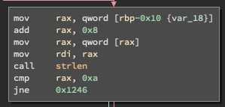

Upon running the program, the program required me to provide an argument along with ./program. Reading the disassembled code, I also found the agreement has to

be of a certain length from strlen. Using disassembled code and ltrace I could 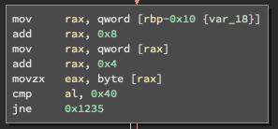not find the required length. After looking for a bit longer I realised the size of string needed to be 10 from 0xa. This is the case since a is 10 in hex. I also found to access the flag section it compared something 0x40 which is @. So, I did a lot of guess and check and found nothing. So, I looked up at the solutions and said the fifth character needs to be @. This could possibly be the case from it moving 0x4 to rax, and then movzx eax, byte [rax].

The flag was flag{aaaa@aaaaa} which happened to be my input.

